**Philadelphia University**



**Faculty of Information Technology**

**Department of Software Engineering**

**Examination Paper**

**Lecturer : Ms. Enas Al-Naffar**

**Coordinator : Mr. Saeb Ali**

**Internal Examiner: Dr. Samer Hanna**

**Computing Ethics (721240) Final Exam 2nd semester** **2013-2014**

**Date: 11th June, 2014**  **Section: 2**   **Time**: **120 Minutes**

**Information for Candidates**

1. *This examination paper contains 6 questions total 40 marks*
2. *The marks for parts of questions are shown in round brackets.*

**I. Basic Notions**

*Objectives: The aim of the question is to evaluate your knowledge and skills concerning with the basic concepts of* ***Computing Ethics***

**Question 1: [15 marks - 1 mark each]**

**Choose the correct answer:**

1.       Internet advertising is negatively affected by

(a) auction fraud;

(b) click fraud;

(c) stock fraud;

(d) digital forgery;

2.       Worms are

(a) software that installs itself without authorization;

(b) software that replicates itself;

(c) web crawlers;

(d) hidden messages;

3.       Sending millions of requests to web server is

(a) fraud;

(b) hacking;

(c) a denial-of-service attack;

(d) spam;

4.       A firewall

(a) prevent all access to a resource;

(b) spam;

(c) blocks phishing;

(d) filters outside access to computers via the Internet;

5.       Ease of collecting data raises issues of

(a) free speech;

(b) protection of children from abuse;

(c) privacy;

(d) intellectual property;

6.       Analyzing and searching databases to find patterns and to enable analysis is

(a) hacking;

(b) data mining;

(c) a privacy violation;

(d) a free-speech violation;

7.       Predicting behavior of an individual based on data analysis is

(a) computer profiling;

(b) data mining;

(c) a claim right;

(d) a denial-of-service attack;

8.       One technical solution to the problem of privacy is

(a) laws;

(b) processing speed;

(c) mass storage;

(d) encryption

9.    The social purpose of recognizing intellectual property rights has been

(a) to enable maximum profit;

(b) to encourage innovation;

(c) to discourage sharing;

(d) to discover geniuses;

10. Which of the following is an example of biometrics:

(a) Face recognition.

(b) Fingerprints.

(c) Voice print

(d) All of the above.

11.     Derivative works are regulated by

(a) patent;

(b) trademarks;

(c) trade secrets;

(d) copyright;

12.    The music industry has faced significant difficulty with

(a) windows media player;

(b) peer-to-peer file sharing;

(c) music sent as email;

(d) None of the above;

13.   The term “free software” means

(a) software to borrow;

(b) unlicensed software;

(c) licensed software with permission to copy freely;

(d) low-cost software;

14. Brand names and logos are regulated by:

* 1. Trademarks
  2. Patent
  3. Trade secrets
  4. Copyright

15. An ethical theory that focuses on consequences:

(a) deontological

(b) utilitarianism

(c) Natural rights

(d) None of the above

### II. Familiar Problems Solving

### *Objectives: The aim of the question is to evaluate your basic knowledge of the key aspects of the lectures material and your ability to solve familiar problems.*

**Question 2: [11 marks]**

### What fears and concerns does the introduction of computers and technology into work bring? *(Two Point – 2 marks)*

Unemployment

High cost

* + - 1. What particular changes has IT made in work life? *(two points – 2 marks)*

Changes in work hierarchy

New concepts like offshoring and Inshoring

* + - 1. When it is acceptable for the employer (boss) to read the emails of his employees? *(Two points – 2 marks)*

When the employee is on a vacation

When there is a leak in critical information

* + - 1. What is Telecommuting? Give Two advantages and Two disadvantages of telecommuting. *(5 marks)*

Telecommuting is :

Working from places other than the offices , i.e from home

Advatanges:

Saves transportation costs

Reduces traffic jam

Disadvantages:

Security concerns

Overhead cost on the employees

**Question 3**:  **[2 marks, 1 mark each]**

Explain how “privacy” can be considered as a:

* + - 1. Negative right (liberties)

No one should violate anyone's privacy

* + - 1. Positive right (claim right)

There should be an obligation on governments and organization to protect individuals' privacy

### Question 4:[4 marks – 2 marks each]

Consider the following two figures. What crime category does each one represent?

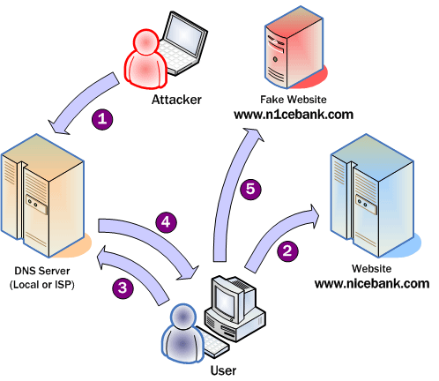

Figure A: Pharming

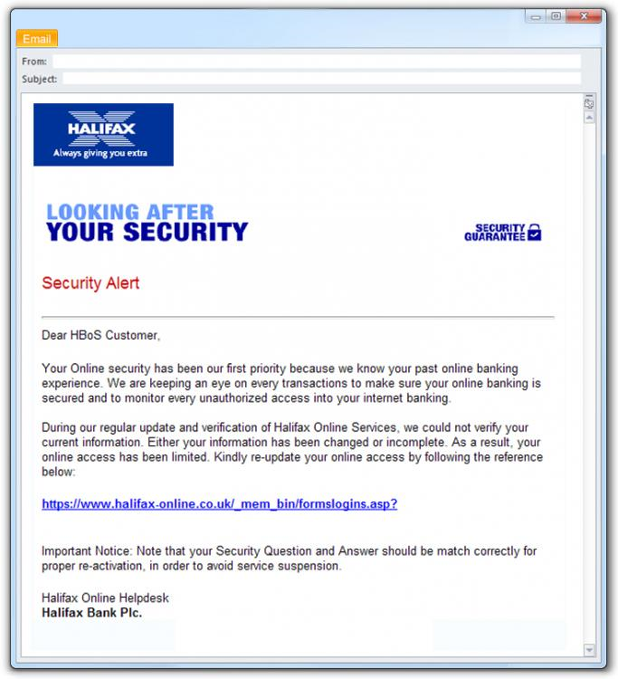

Figure B: Phishing

**Question 5:** **[4 marks]**

Jolene collects software from friends. She copies the installation CD, installs the software on her computer, and gives it a try. Generally she then does nothing more with it, but she has plenty of disk space and so doesn't usually delete it. "I might need it someday to open a file I receive" is what she says to herself. In fact, she seldom does even that. When she finds software she *likes,* she usually buys it.   
Is this act considered Fair use or Not? Justify your answer using Fair use principles.

Purpose of use: non-commercial

Amount used: whole

Nature of use: Personal

Effect on income: doesn't affect the income since she buys the software when she likes it

So it may be considered as fair use

**III. Unfamiliar Problems Solving**

Objectives: *The aim of the question is to evaluate your knowledge of the key aspects of the lectures material and your ability to solve unfamiliar problems.*

**Question 6:** **[4 marks, 2 marks each]**

Suppose an online technical site has space for users to post Anonymous comments. Recently, however, the posting section is being abused, as some users post rude comments directed at other users.

In order to solve this problem, the site decided that users will continue to be allowed to use Anonymous comments, but must register with a real name, and the real names will be revealed to anyone who complains.

1. Does this solution violate user's privacy? Justify your answer.

If this was not stated in the privacy policy of this site then yes it violates users' privacy

1. Suggest an enhancement or an alternative solution to the above problem.

Names should be revealed to admins only not any user who complains, then the admin can take an appropriate action

The privacy policy of the site should inform users about this action

***Good Luck***